MACH4METAL

Metalworking machinery
Transito 21,
6909 DA BABBERICH
Netherlands
Tel. +31 (0)316 – 247123
Fax. +31 (0)316 - 247956
info@mach4metal.com
www.mach4metal.com

Account No: 66.52.13.883
IBAN : NL33 INGB 0665 2138 83
BIC : INGBNL2A

CNC bed milling CME BF-06
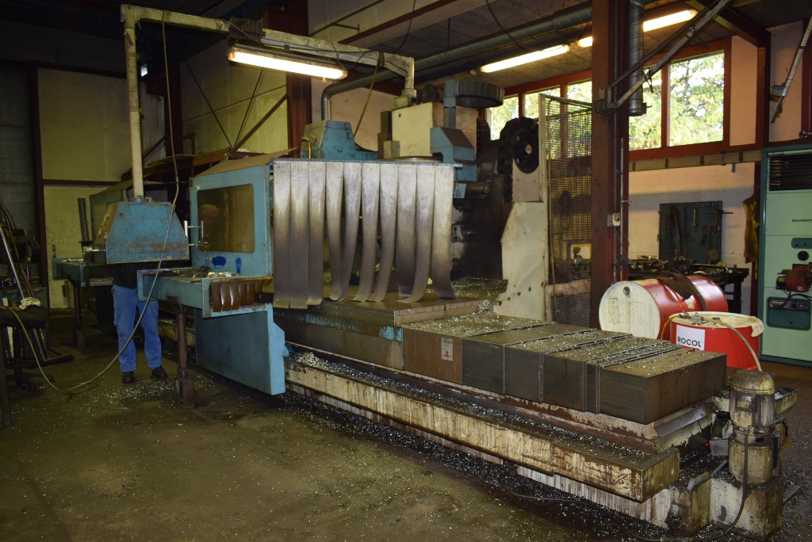
- Make : CME Spain
- Type : BF 06
- Serial. No : 06 - 12
- Age : 1995

- Table dimensions:
- Length : 4200
- Width : 1200
- Load Kg : 1000
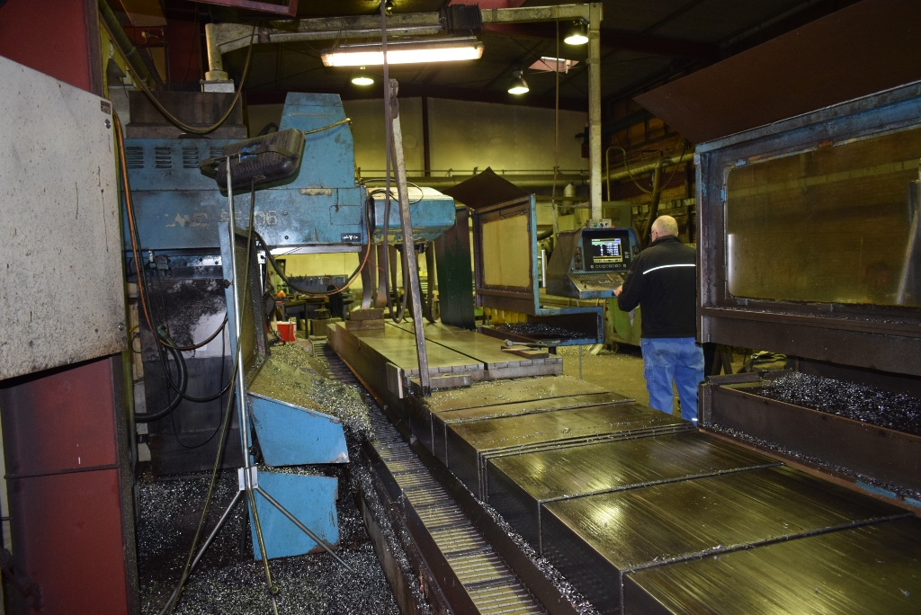
- Working area
- X - Travel : 4000
- Y - Travel : 1000
- Z - Travel : 1000
- Min. spindle – table : 55
- Max. spindle – table : 1.055

- Spindle : Bt 50
- Speeds : 3.000 U/min.
- Milling head power : 22 kW
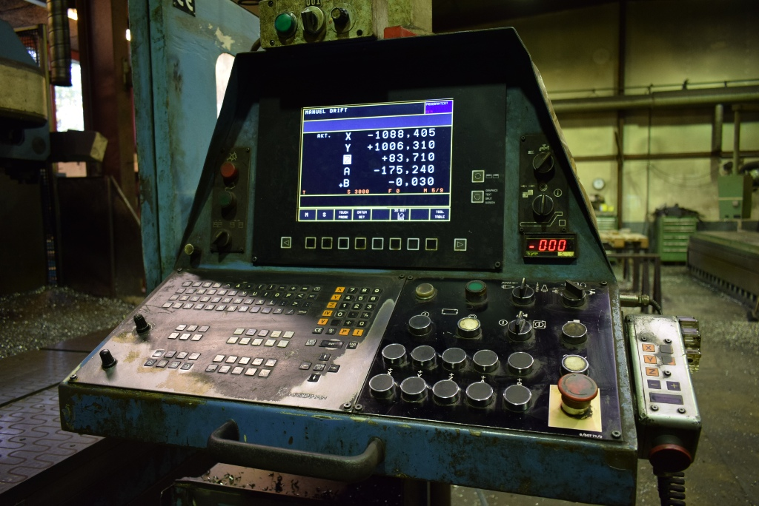

- Dimensions
- Length : 12.500
- Width : 5.200
- Height : 3.300
- Weight : 23.000

- CNC Control HeidenHain TNC
- Chain ATC 30 positions
- Chip conveyor
- Auto indexing head A/B Axis 30 Gr

Please Note: The above information has been obtained to the best of our ability and belief from, and from the manufacturers where possible. It is given in good faith, but its accuracy can not be guaranteed. Accordingly, it will not form a representation or constitute contractual terms. We advise you to check any vital details!

